Kryptos K4 Observations
Author: warrenzevonrocks@bell.net
Leading thoughts
The solution to K3 was a transposition cipher. One of the vital steps was a reordering of the rows from 0123456 to 3041526.
This is depicted in an animated web demonstration on the Realm of Twelve website.
http://www.realmoftwelve.net/speculation/k3solution.html
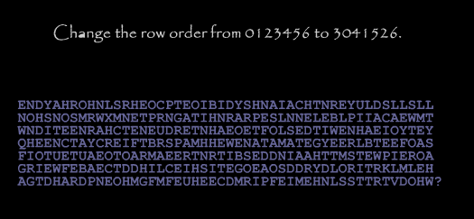
Upon learning of the Kryptos puzzle and examining how each of K1 through K3 were solved, the one thing that always struck me as interesting was how on earth someone could have figured out the algorithm of changing the rows as depicted above. I later discovered that a "skip" decryption technique could yield the same result mathematically which was fascinating. However, I digress. I believe Sanborn encrypted the plain text using a swapping of rows in this fashion and expected the cryptographer to solve it in the same fashion.
So what is the significance of 3041526? There probably isn't any point in reading too much into it. However, my thought is that Sanborn wanted to ensure that no one would solve K4 until K1 through K3 were solved. One way that he could help ensure this would happen would be by using some random piece of information from K3 (since I believe K1 and K2 were trivial to crack in comparison to K3).
Therefore, let's see what happens if we use 3041526 as part of a solution to K4. This is something that I came up entirely by myself and I have yet to read anything on the internet related to such an attempted solution.

Attempted Solution
So we have K4 as follows:
OBKRUOXOGHULBSOLIFBBWFLRVQQPRNGKSSOTWTQSJQSSEKZZWATJKLUDIAWINFBNYPVTTMZFPKWGDKZXTJCDIGKUHUAUEKCAR
Step 1 - Keyed Vigenere
Let's run K4 through a keyed Vigenere using the standard "KRYPTOS" alphabet keyword and a password of 3041526 or "DAEBFCG".
A quick web-based tool is available from the Rumkim website.
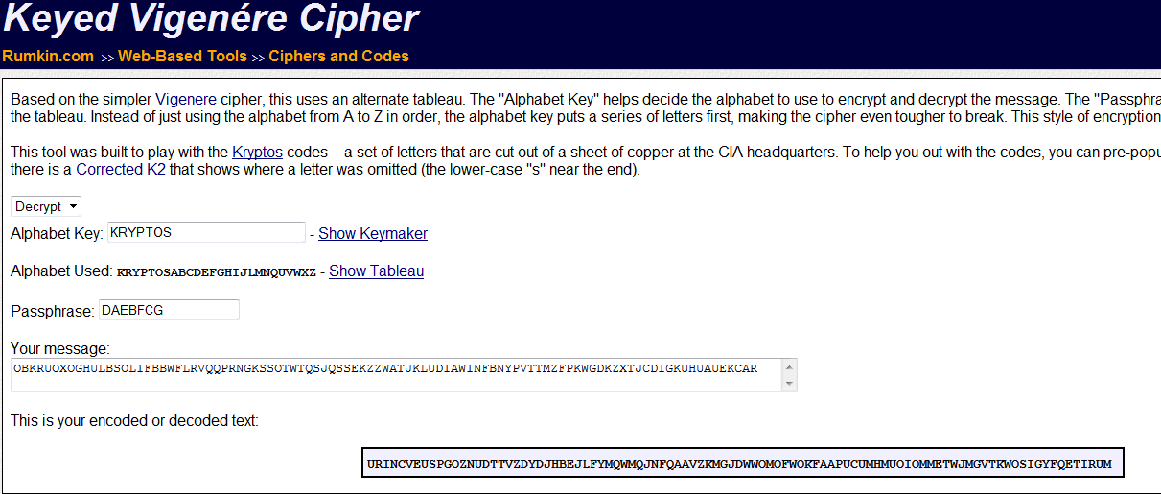
This yields the following:
URINCVEUSPGOZNUDTTVZDYDJHBEJLFYMQWMQJNFQAAVZKMGJDWWOMOFWOKFAAPUCUMHMUOIOMMETWJMGVTKWOSIGYFQETIRUM
On the surface this doesn't seem like any progress. The kappa is 0.4102 which is a too far off from English ideal of 0.665. However, the original kappa of the cipher text is 0.3608 so maybe we are moving in the right direction?
It is possible that Sanborn did further character manipulation after this substitution as well. I believe a very important clue in solving K4 is the raised letters YAR in K3. There have been countless elaborate theories into what this means although no one really knows for sure. My thought is, let's take it at face value. Sanborn is not a mathematician, in fact he is not a cryptographer either. He is an artist. Is it possible that the raised letters are trying to point out that he used a Railfence cipher as a secondary mechanism to encrypt the plain text?
Step 2 - Railfence
Going with the theory that there are at least two parts to the K4 solution and the first part is a keyed Vigenere, let's play with some RailFence combinations and see what we find.
Using the Rumkim website, if we take the output from step 1 and run it through a Railfence cipher with 3 rails we get gibberish. However, if you look closely you can see the word BERLIN start to form. Refer to the screenshot below. Note that Sanborn has indicated that the word BERLIN is in fact in the plaintext of the deciphered K4.
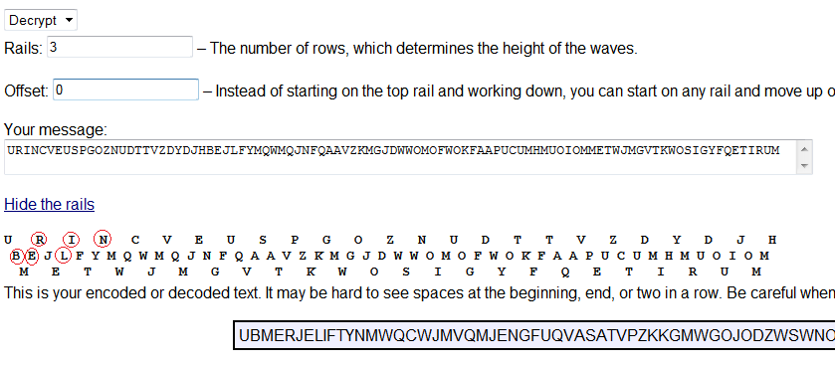
Could this be a coincidence or am I on the right track?
Step 3 - Railfence - Words start to immerge
A railfence of 3 yielded an interesting result so I kept hacking at it. Without going into deals I found that a railfence of 7 with an offset of 7 yielded some very intriguing results. However, before the results were seen I had to add two characters at the end of the text. I used YA although you can use spaces or XX or whatever since it does not change the result of my observation.
I.e
URINCVEUSPGOZNUDTTVZDYDJHBEJLFYMQWMQJNFQAAVZKMGJDWWOMOFWOKFAAPUCUMHMUOIOMMETWJMGVTKWOSIGYFQETIRUMYA
Here is the result of the railfence:
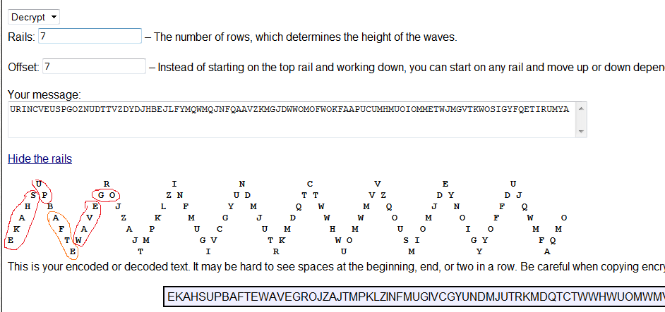
We still don't have a solution however, it is hard to believe that this is a coincidence! The words "SHAKE", "UP", "WAVE", "GO" and possibly "AFTER" start to immerge.
I'm thinking since the cipher was done shortly after the collapse of the Berlin wall, it would have been on everybody's mind. It's not a stretch to believe that the plaintext may be something to the effect of the "The world was shaken up after the fall of the Berlin wall and it sent shock waves around the world".
So that's it. I haven't been able to make any further progress based upon the time I've spent on the puzzle but this remains the most profound discovery I have found personally and from my opinion what I've read on the internet.
**Important Side Note**
Since I am divulging all of the information I have, I have one more information piece of information that I have extracted based upon my analysis of the K4 cipher text. One of the vital tools a cryptographer has is the measure of index of coincidence of characters. If you examine K4 in detail you'll see some patterns of repetition.
One of my observations that I find very interesting is the use of a duplicate character when a character sequence repeats.
For example:
The letters FB repeat and there is a second B. I.e. FBB/FB
The letters QS repeat and there is a second S. I.e. QS/QSS
The letters KZ repeat and there is a second Z. I.e. KZZ / KZ
I therefore sense a pattern here that seems a little to formulated to be pure random coincidence. I'm not sure what it means but my supporting theory is that Sanborn has altered the cipher text to help prevent the usual cryptanalysis from revealing to much information. Is it possible that these 3 repeated characters are somehow tied to the raised 3 characters Y, A and R? If Sanborn is giving a clue that these characters need to be replaced it may be that the solution to K4 is a simple Vigenere cipher although the cipher text cannot simply be taken at face value.
Alas, I have set a personal goal of cracking K4 by the end of April 2012 and I have not accomplished it. Therefore, as promised I have divulged what I deem to be the most valuable pieces of information that will hopefully lead someone with more experience than myself on the right path to solve it.
If you do use this information and it leads to a solution I would hope that you acknowledge my contribution as the impetus to the solution.
Summary
I don't believe Kryptos K4 has ever been solved because it is not a simple single cipher. Alternately it may be a single cipher but the cipher text has been altered in a systematic fashion. If we perform a Vigenere cipher as the first step in a two step process we get a step further. The Kryptos structure uses a Vigenere for K1 and K2 and a transposition for K3. Therefore, a combination of a poly-alphabetic substitution followed by a transposition cipher would be a feasible solution technique for K4. If we combine a Vigenere cipher with a Railfence we start to see several words emerge. This is either a complete coincidence or a partial solution to K4 in which no one to date has identified.
Thoughts?

